MIE1622 Assignment 1 Discussions

**2. Analyze your results:**

**2.1 Charts and plots**

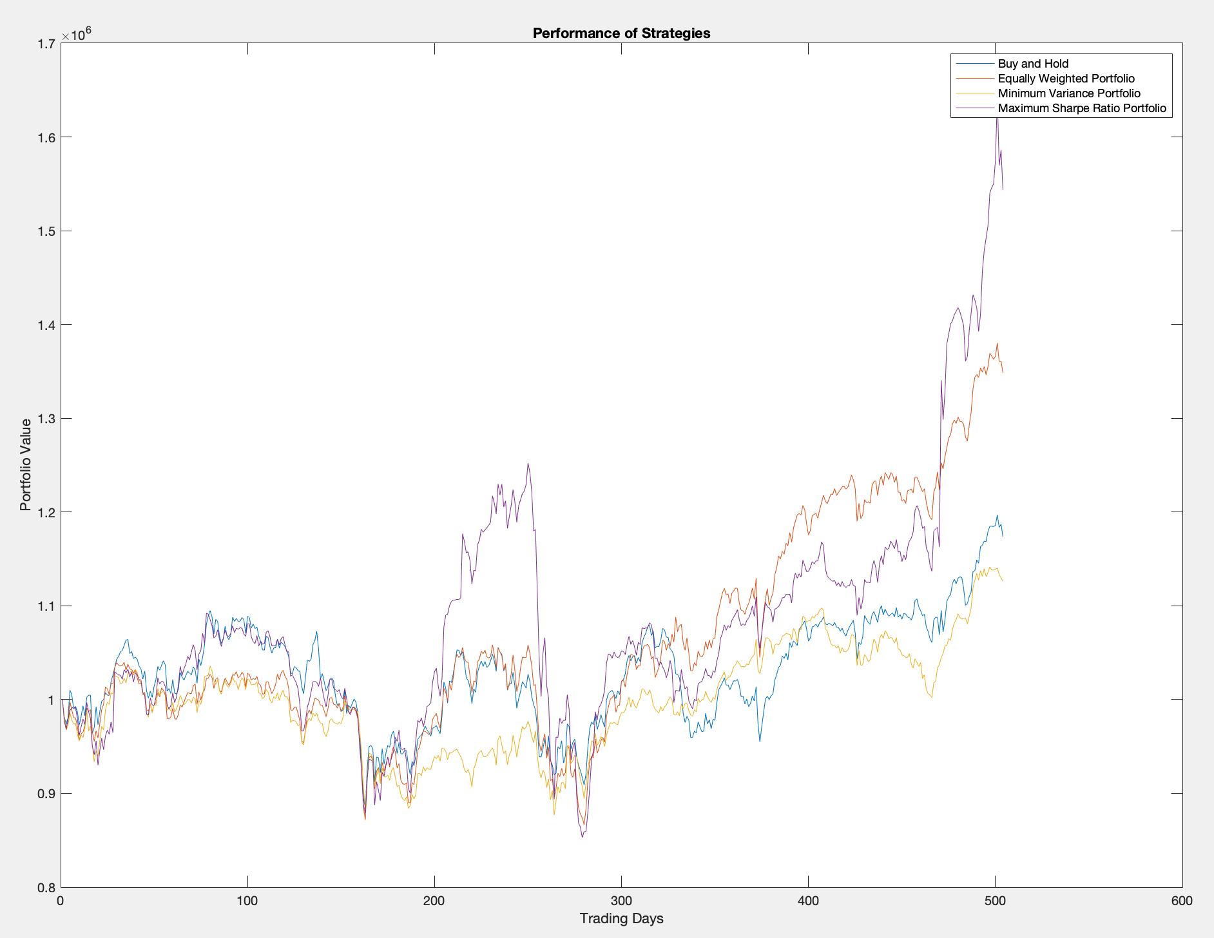

*Figure 1. Performance of Strategies*

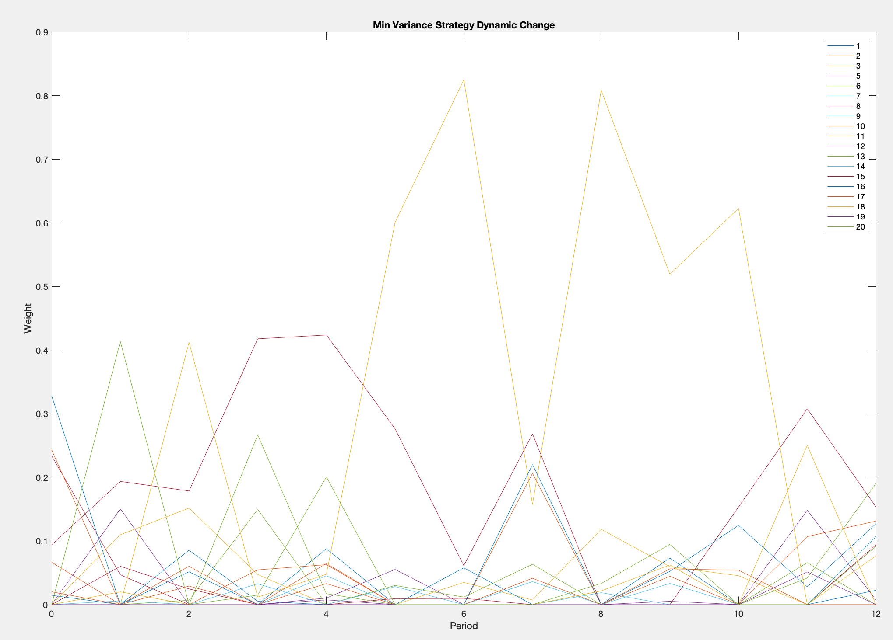

*Figure 2. Dynamic change in portfolio allocations for the Min. Variance Strategy*

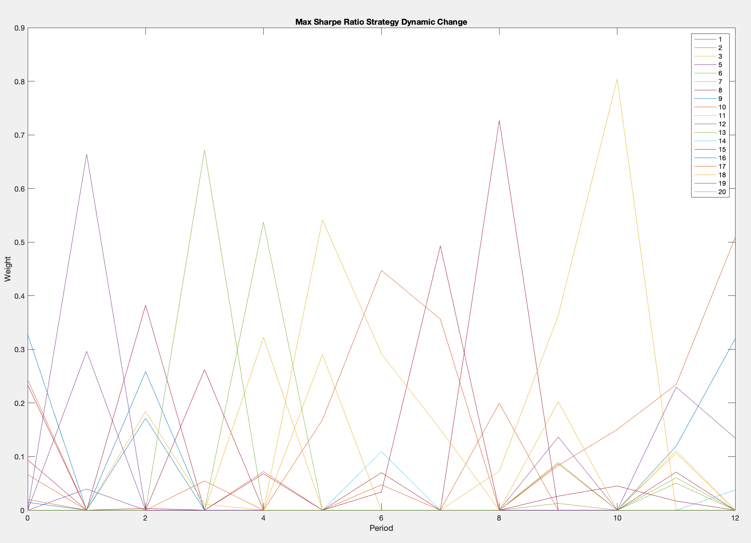

*Figure 3. Dynamic change in portfolio allocations for the Max. Sharpe Ratio Strategy*

**2.2 Q: Compare your trading strategies and discuss their performance relative to each other. Which strategy would you select for managing your own portfolio and why?**

As seen in figure 1, the “Max. Sharpe Ratio” strategy performed consistently well throughout the 2-year period when compared to the other 3 strategies, ranking the highest in final portfolio value. The “Buy and Hold” strategy, although performed similarly well to the “Max. Sharpe Ratio” in the beginning (approx. first 180 days), is ranked third in the final portfolio value. The “Equally Weighted” and “Min. Variance” strategies performed similarly in the beginning of the 2-year period, but differentiated towards the end, resulting in the “Equally Weighted” ranked second, and “Min. Variance” ranked last in final portfolio values.

Since the “Max. Sharpe Ratio” strategy performed generally better throughout the 2-year period, I would select the “Max. Shape Ratio” for managing my own portfolio. This is not surprising, since the other strategies lack comprehensive analysis of historical data, with the “Min. Variance” only taking into consideration fluctuations in variance. The “Max. Sharpe Ratio” maximizes expected return on top of the risk-free return, while minimizing variance.

**3. Discuss possible improvement to your trading strategies:**

**3.1 Q: Test your MATLAB program for different variations of your strategies. Discuss if you are able to achieve better results.**

**3.1.1 Test 1: Selecting “1/n” at the beginning of period 1 and hold until the end of period 12.**

This test is implemented by modifying the existing strat_buy_and_hold, as seen in figure 4.

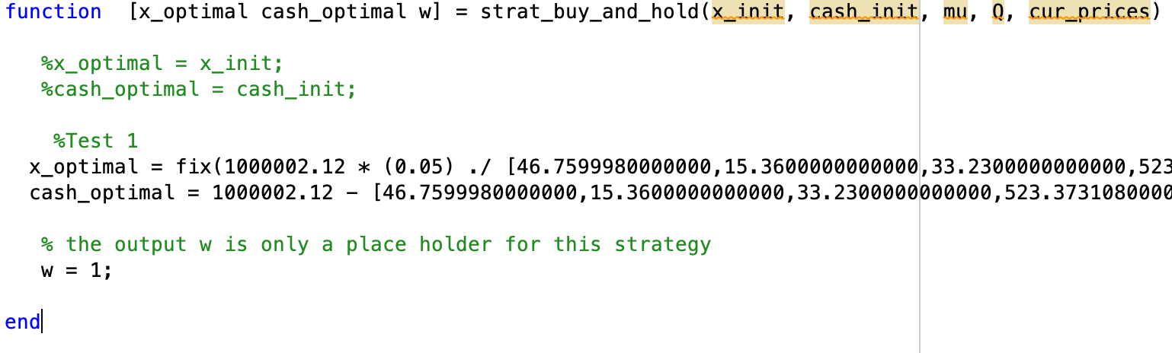

*Figure 4. modifications to strat_hold_and_buy for Test 1*

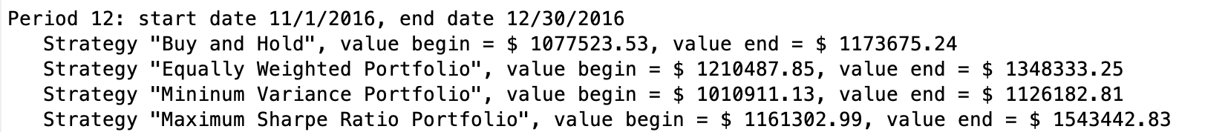

*Figure 5. Portfolio performance for the 12th period of each strategy before tests have been implemented*

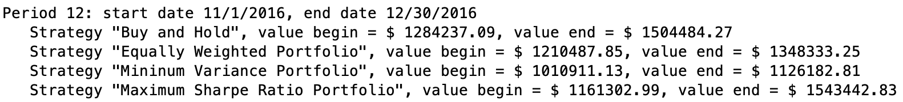

*Figure 6. Final portfolio performance after changes in Test 1 have been made*

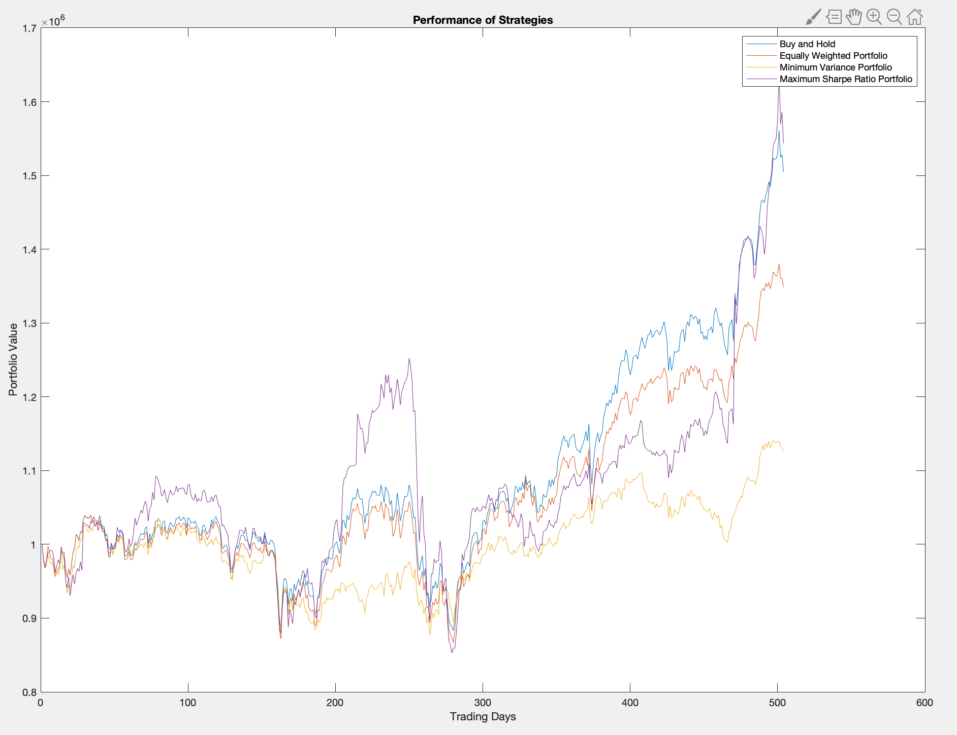

*Figure 7. Portfolio performance after implementation of Test 1*

As seen in figures 5 and 6, applying the Test 1 modifications to strat_buy_and_hold allows for the final portfolio value to increase by $330,809, a 28.2% increase. As seen in figure 7, the final portfolio value obtained with Test 1 is comparable to that of strat_Max_Shape.

**3.1.2 Test 2: Selecting 1/n for the beginning of period 1 for every strategy**

This test is implemented by modifying the following sections of the main file, as seen in figures 8 and 9

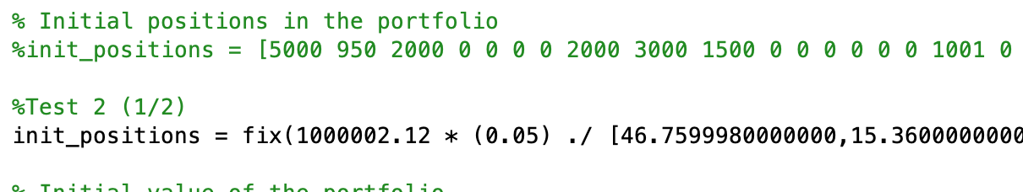

*Figure 8. first modification to the main file for Test 2*

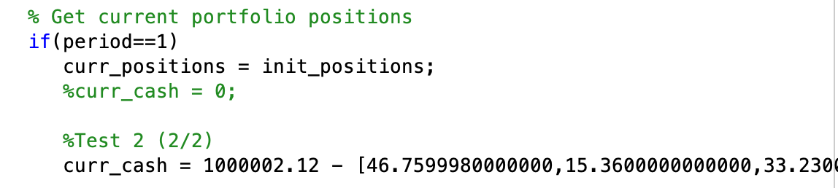

*Figure 9. second modification to the main file for Test 2*



*Figure 10. Final portfolio values for all 4 strategies before implementation of Test 2*

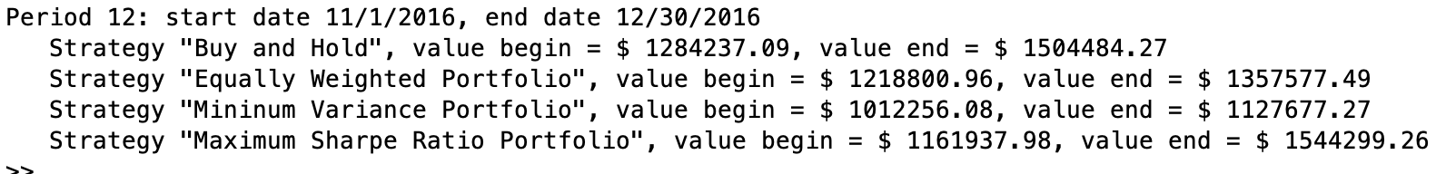

*Figure 11. Final portfolio values for all 4 strategies after implementation of Test 2*

|  |  |  |  |  |
| --- | --- | --- | --- | --- |
| Strategy | Original Portfolio($) | New Portfolio($) | Difference ($) | Percentage Increase (%) |
| Buy and Hold | 1173675.24 | 1504484.27 | 330809.03 | 28.2 |
| Equally Weighted | 1348333.25 | 1357577.49 | 9244.24 | 0.69 |
| Min. Variance | 1126182.81 | 1127677.27 | 1494.46 | 0.13 |
| Max. Sharpe Ratio | 1543442.83 | 1544299.26 | 856.43 | 0.06 |

*Table 1. portfolio performance increase after implementation of Test 2 for every strategy*

As seen in table 1, strategy Buy and Hold experiences that highest percentage increase after implementation of Test 2, while the other 3 strategies experience less than 1 percent increase each.

**3.2 Suggest any improvements of the trading strategies implemented**

**3.2.1 Suggestion 1: Improving cash validation algorithm**

In the current program, cash validation is performed by subtracting 1 of every stock at a time until the cash amount is greater than zero. This methodology makes sure that there is enough cash for stock purchases, but cash amount as well as stock weight are not fully optimized. The program can benefit from a validation methodology that subtracts stocks based on the stocks with lower prices, as well as the current optimization strategy. This will ensure that the cash account is minimize and that the resulting portfolio weights reflect the current optimization strategy.

**3.2.2 Suggestion 2: Making portfolio selection less dependent on historical data**

Both strategies 3 and 4 are part of the mean-variance optimization (MVO) methodology, which uses historical statistics (covariance and expected returns) to evaluate portfolio selection. This process requires a high number of historical data to be reliable, and the resulting portfolio is rather sensitive to changes in the expected returns. Also, since the model is “hard-wired” to produce return or variance-based results, the resulting portfolio can be undiversified. MVO can be improved by making it less dependent on historical data, such as with the Black-Litterman Model, which introduces subjective views of the investor into the optimization model, and bases the expected return on market capitalization instead of historical data. The resulting model has a more accurate expected return estimation, better portfolio diversifications, and allows for investors to influence the selection process.